### **Networks Fundamentals II Homework: In a Network Far, Far Away!**

### **Mission 1**

**Issue**: Due to the DoS attack, the Empire took down the Resistance's DNS and primary email servers.

* The Resistance's network team was able to build and deploy a new DNS server and mail server.
* The new primary mail server is **asltx.l.google.com** and the secondary should be **asltx.2.google.com**.
* The Resistance (starwars.com) is able to send emails but unable to receive any.

Your mission:

* Determine and document the mail servers for starwars.com using NSLOOKUP.

**nslookup -type=MX starwars.com**  
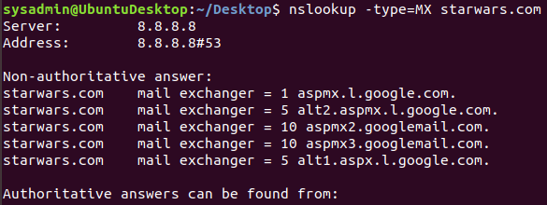

* Explain why the Resistance isn't receiving any emails.

**The Resistance isn’t receiving any emails because their MX records are not set to the correct primary and secondary mail servers as provided.**

**asltx.l.google.com** and **asltx.2.google.com** **are not part of the MX records.**

**Showing as below:**

**starwars.com mail exchanger = 5 alt1.aspx.l.google.com.**

**starwars.com mail exchanger = 5 alt2.aspmx.l.google.com.**

**starwars.com mail exchanger = 10 aspmx3.googlemail.com.**

**starwars.com mail exchanger = 1 aspmx.l.google.com.**

**starwars.com mail exchanger = 10 aspmx2.googlemail.com.**

* Document what a corrected DNS record should be.  
  **Corrected DNS should show the following:**

**starwars.com mail exchanger = 1 asltx.l.google.com.**

**starwars.com mail exchanger = 5 asltx.2.google.com.**

### **Mission 2**

**Issue**: Now that you've addressed the mail servers, all emails are coming through. However, users are still reporting that they haven't received mail from the theforce.net alert bulletins.

* Many of the alert bulletins are being blocked or going into spam folders.
* This is probably due to the fact that theforce.net changed the IP address of their mail server to 45.23.176.21 while your network was down.
* These alerts are critical to identify pending attacks from the Empire.

Your mission:

* Determine and document the SPF for theforce.net using NSLOOKUP.

**nslookup type=TXT theforce.net**

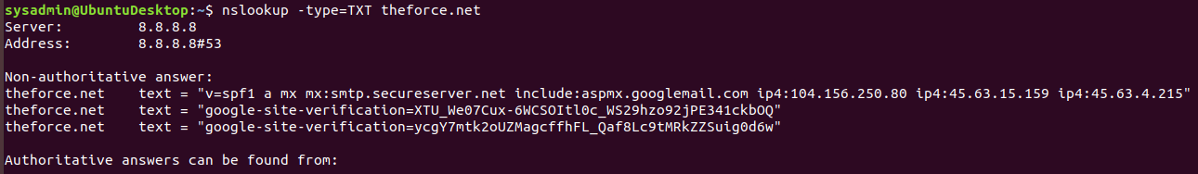

**theforce.net text = "v=spf1 a mx mx:smtp.secureserver.net include:aspmx.googlemail.com ip4:104.156.250.80 ip4:45.63.15.159 ip4:45.63.4.215"**

* Explain why the Force's emails are going to spam.  
  **The Force has not updated their DNS text record to reflect the required SPF pointer to their recently changed mail server “45.23.176.21”.**
* Document what a corrected DNS record should be.  
  **Corrected DNS record should be:**

**theforce.net text = "v=spf1 a mx mx:smtp.secureserver.net include:aspmx.googlemail.com include:45-23-176-21.lightspeed.rcsntx.sbcglobal.net ip4:104.156.250.80 ip4:45.63.15.159 ip4:45.63.4.215"**

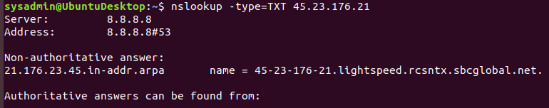

### 

### 

### 

### **Mission 3**

**Issue**: You have successfully resolved all email issues and the resistance can now receive alert bulletins. However, the Resistance is unable to easily read the details of alert bulletins online.

* They are supposed to be automatically redirected from their sub page of resistance.theforce.net to theforce.net.

Your mission:

* Document how a CNAME should look by viewing the CNAME of www.theforce.net using NSLOOKUP.

**nslookup -type=CNAME www.theforce.net**

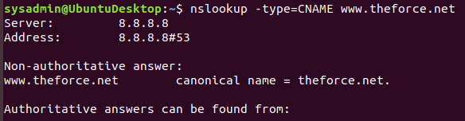

**www.theforce.net canonical name = theforce.net.**

* Explain why the sub page of resistance.theforce.net isn't redirecting to theforce.net.

**The DNS CNAME record is missing a reference from resistance.theforce.net to theforce.net**

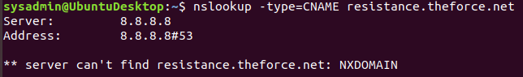

* Document what a corrected DNS record should be.  
  **Corrected DNS record should be.**

**www.theforce.net canonical name = theforce.net.**

**resistance.theforce.net canonical name = www.theforce.net.**

### 

### **Mission 4**

**Issue**: During the attack, it was determined that the Empire also took down the primary DNS server of princessleia.site.

* Fortunately, the DNS server for princessleia.site is backed up and functioning.
* However, the Resistance was unable to access this important site during the attacks and now they need you to prevent this from happening again.
* The Resistance's networking team provided you with a backup DNS server of: ns2.galaxybackup.com.

Your mission:

* Confirm the DNS records for princessleia.site.

**nslookup -type=NS princessleia.site**  
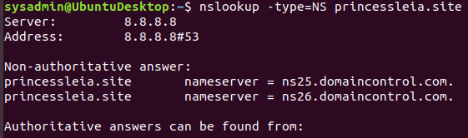

**Current name servers:**

**princessleia.site nameserver = ns26.domaincontrol.com.**

**princessleia.site nameserver = ns25.domaincontrol.com.**

* Document how you would fix the DNS record to prevent this issue from happening again.  
  **Need to add a reference to the backup DNS server:**

**princessleia.site nameserver = ns25.domaincontrol.com.**

**princessleia.site nameserver = ns2.galaxybackup.com.**

### 

### **Mission 5**

**Issue**: The network traffic from the planet of Batuu to the planet of Jedha is very slow.

* You have been provided a network map with a list of planets connected between Batuu and Jedha.
* It has been determined that the slowness is due to the Empire attacking Planet N.

Your Mission:

* View the [**Galaxy Network Map**](https://drive.google.com/file/d/1NJLktWPE07RLQ0V6CDDqdoNvtsHX9HWj/view?usp=sharing) and determine the OSPF shortest path from Batuu to Jedha.  
  **The “OSPF” shortest path from “Batuu” to “Jedha”:**

**D C E F J I L Q T V Jedha**

**1 2 1 1 1 1 6 4 2 2 2 -----> 23 hops**

* Confirm your path doesn't include Planet N in its route.  
  **It’s not going through Planet N as per the above path.**
* Document this shortest path so it can be used by the Resistance to develop a static route to improve the traffic.  
  **Planet Batuu → D → C → E → F → J → I → L → Q → T → V → Planet Jedha**

### 

### **Mission 6**

**Issue:** Due to all these attacks, the Resistance is determined to seek revenge for the damage the Empire has caused.

* You are tasked with gathering secret information from the Dark Side network servers that can be used to launch network attacks against the Empire.
* You have captured some of the Dark Side's encrypted wireless internet traffic in the following pcap: [**Darkside.pcap**](https://drive.google.com/file/d/1NHXWngoXHNWk-U8HDJo7h4GBIXn7EEmr/view?usp=sharing).

Your Mission:

* Figure out the Dark Side's secret wireless key by using Aircrack-ng.  
  + Hint: This is a more challenging encrypted wireless traffic using WPA.
  + In order to decrypt, you will need to use a wordlist (-w) such as rockyou.txt.

**aircrack-ng Darkside.pcap -w /usr/share/wordlists/rockyou.txt**

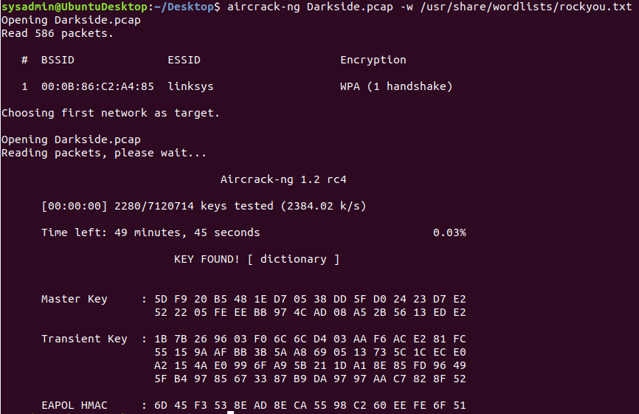

**KEY FOUND! [ dictionary ]**

* Use the Dark Side's key to decrypt the wireless traffic in Wireshark.  
  + Hint: The format for they key to decrypt wireless is <Wireless_key>:<SSID>. **Preferences > Protocols > IEEE 802.11 > Enable Decryption > Decryption Keys > Edit > wpa-pwd key=dictionary**

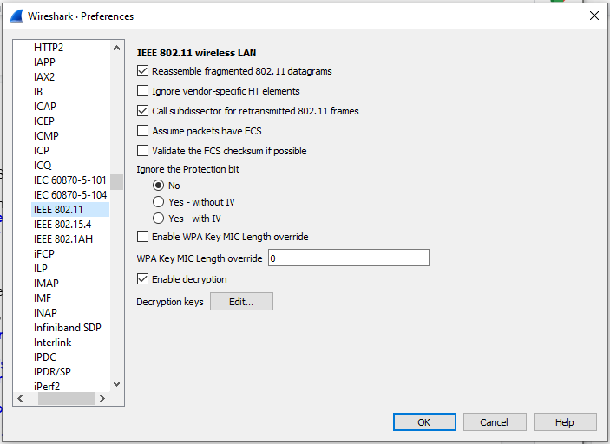

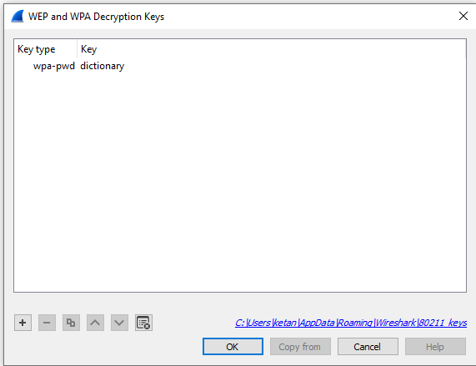

* Once you have decrypted the traffic, figure out the following Dark Side information:  
  + Host IP Addresses and MAC Addresses by looking at the decrypted ARP traffic.  
    **ARP Protocol Specific Addresses:**

**IP Addresses MAC Addresses**

**Target’s 172.16.0.101 is at Cisco-Li_e3:e4:01 (00:13:ce:55:98:ef)**

**Sender’s 172.16.0.1 is at IntelCor_55:98:ef (00:0f:66:e3:e4:01)**

**Additional IPs of interest:**

**IP Addresses MAC Addresses**

**172.16.0.9 is at 00:14:bf:0f:03:30**

**68.9.16.30 is at 00:0f:66:e3:e4:01 same mac as \**

**68.9.16.25 is at 00:0f:66:e3:e4:01 same mac as - 172.16.0.1**

**10.1.1.50 is at 00:0f:66:e3:e4:01 same mac as /**

* + Document these IP and MAC Addresses, as the resistance will use these IP addresses to launch a retaliatory attack.

**IP Addresses MAC Addresses**

**Target’s 172.16.0.101 is at Cisco-Li_e3:e4:01 (00:13:ce:55:98:ef)**

**Sender’s 172.16.0.1 is at IntelCor_55:98:ef (00:0f:66:e3:e4:01)**

**Watch gateway:**

**IP Addresses MAC Addresses**

**Destination: 172.16.0.9 is at 00:14:bf:0f:03:30**

**Location: http://172.16.0.9:5431/dyndev/uuid:0014-bf0f-0330000099dc\r\n**

### 

### 

### 

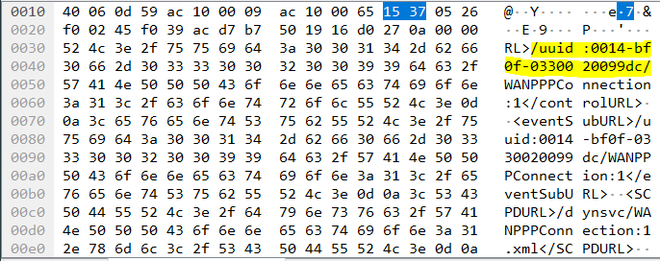

### **Mission 7**

As a thank you for saving the galaxy, the Resistance wants to send you a secret message!

Your Mission:

* View the DNS record from Mission #4.
* The Resistance provided you with a hidden message in the TXT record, with several steps to follow.
* Follow the steps from the TXT record.
  + **Note**: A backup option is provided in the TXT record (as a website) in case the main telnet site is unavailable
* Take a screen shot of the results.  
  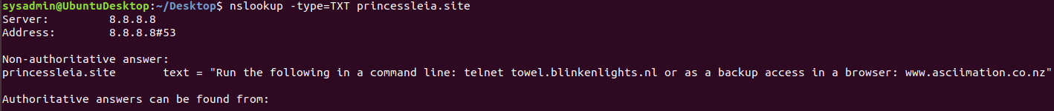**princessleia.site text = "Run the following in a command line: telnet towel.blinkenlights.nl or as a backup access in a browser: www.asciimation.co.nz"**

**telnet towel.blinkenlights.nl**



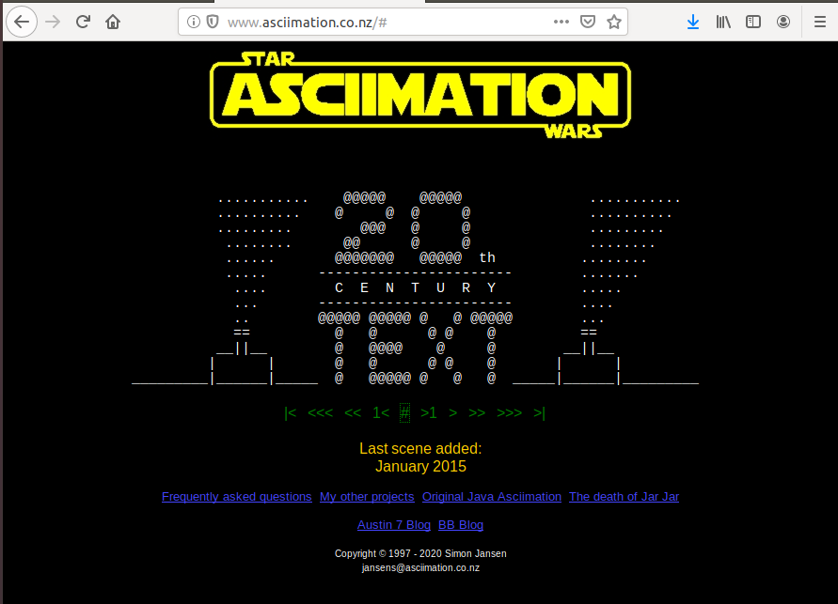

© 2020 Trilogy Education Services, a 2U, Inc. brand. All Rights Reserved.

Ketan V. Patel ✪✪✪✪✪